The colour scheme will be a mixture of pastel pinks and purples, making the website look soft and welcoming, I will not use harsh colours. I will implement an open and simple layout with very clear borders between two aspects of the website, they will not be multi-coloured like my design this is just to give an idea of the definition between elements I will work for.

Address + Links.

NEWS STORIES/ BOTW TV

Gallery, carousel of bands

Youtube Video of upcoming band

A Guide To The World Of Music

Home| News |What’s on| Shop | Projects Search

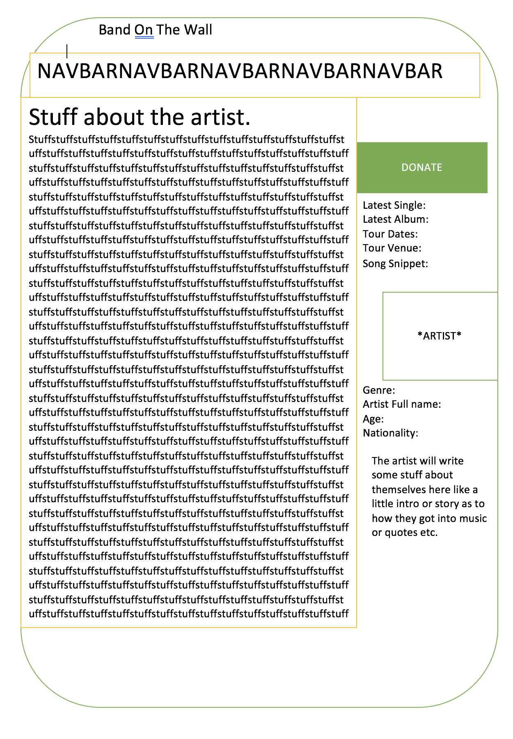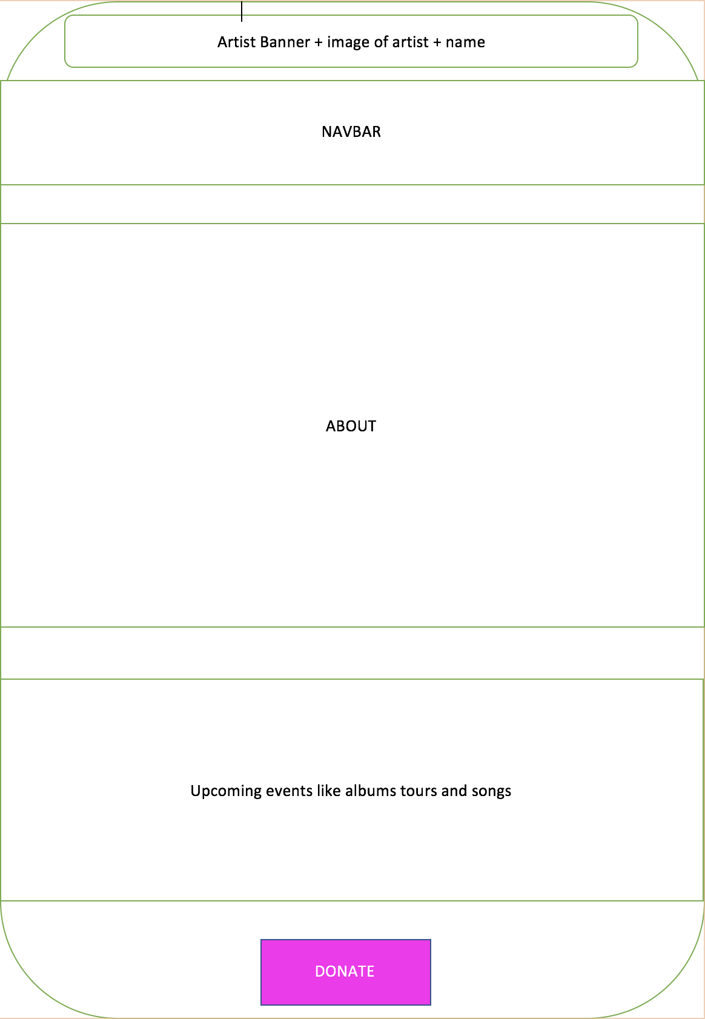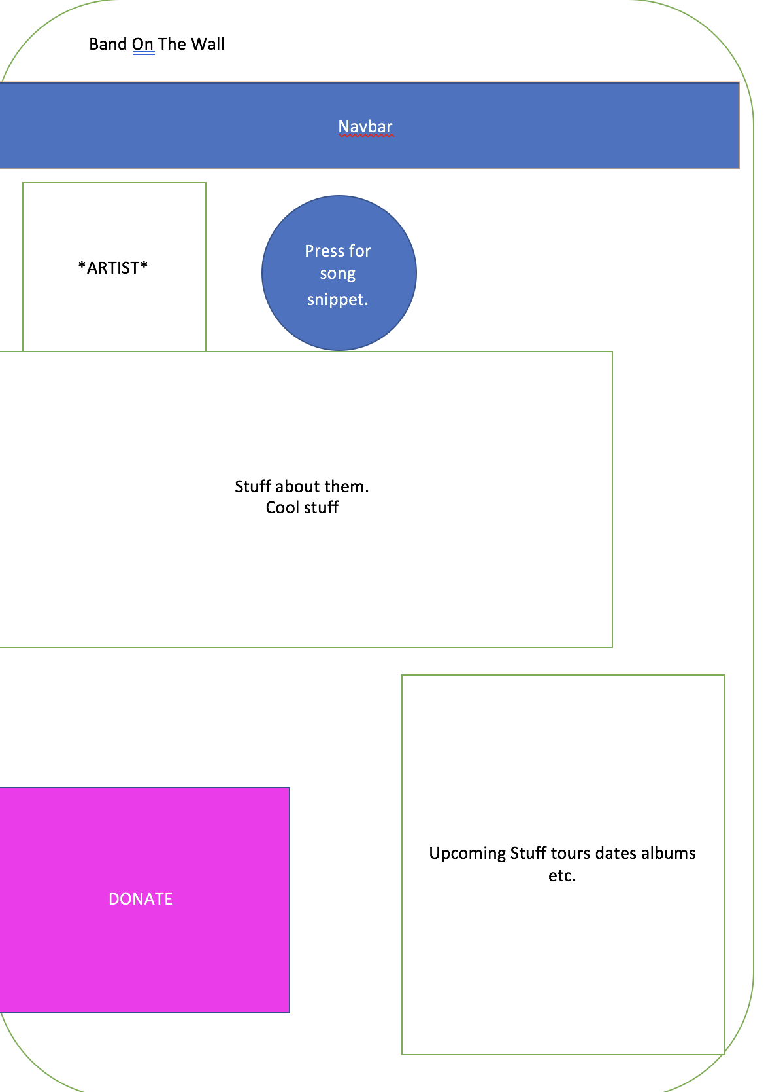

Project Plan

These were a few ideas I had for creating an artist profile on the site they would have profiles of the artists, where they came from, why they started to make music etc. if there are any other band members as well, these would be listed, there would be a section for an image of the band and the donate button for the Band on the wall charity would also be present, it would be brightly coloured. Will start off by creating a basic home page which can act as a hub, I will then create external pages, for example the artist profile. I will then add more elaborate features onto my pages of the website, making them more expensive and easier to use.

Problem Definition Statement

There are many problems that we need to solve by creating this website as a group, the client has said that they want videos on their website, by doing this we will add more functionality onto the website, making it nicer to use and also it will appeal to the audience more. “At it’s heart the new website will be a searchable database for artists, photos, videos and musical genres which will link to other similar artists and musical styles. However, it is essential that this is not just a standard video repository, such as a small-scale YouTube. This website needs to allow the user to go on a journey through the world of music, following the development of musical styles and the artists that best represent them. There should be an element of storytelling within the website that creates a developmental, yet inspirational feel, with links and progression through the website built into the design.”